Our SQL Server T-SQL course includes a Real-time Project "**Banking**"

Please find the database schema (diagram) :

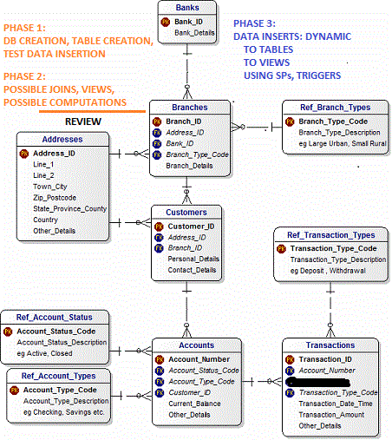

The diagram represents Tables and the relations pertaining to an Online Banking Provider Database.

This database is a part of back-end design from a older Standard Chartered Bank.

Standard Chartered is a British multinational banking and financial services company headquartered in London. It operates a network of more than 1,200 branches and outlets across more than 70. Need to provide Design and Support to stockholders more than 2000 + servers,150+ Applications for this bank

The project implementation involves three phases:

**Phase 1: Database and Table Design**

**Phase 2: Queries and Joins**

**Phase 3: Programming and DML Automation using SPs, Triggers, etc.**

With reference to the given diagram, please perform the following:

STEP 1: Design / Create a database with Files and File groups. Assume size is 100 MB per file for now.

STEP 2: Design / Create Tables with appropriate columns, provide correct/relevant data types and keys. Include Schemas for ease of access (as and where needed).

STEP 3: Define Relations between the tables (based on the arrow marks in the given schema)

STEP 4: Insert some data in each table (minimum of 3 to 10 values in each table) based on the relations. This way you would easily verify the correctness of if the data type for each column.

Please try from your end and me send the solution so that I can verify the same and reply you with mine. Then send you Phase 2 [Query Writing and Joins].

Then later proceed for Phase 3:

